Software Design Specification

AI Powered Hospital Information Management System

Project Code:

HIMS-AI-2526

Internal Advisor:

Mr. Aamir Zia

Project Manager:

Dr. Muhammad Ilyas

Project Team:
Ali Akbar BSCS51F22R036 (TL)
Muhammad Najee Ullah Noon BSCS51F22S043

Submission Date:

Dec 15,2025

_____________________
Project Manager’s Signature

Document Information

Category | Information
Customer | Computer Science , University Of Sargodha
Project | <Hospital Information Management System >
Document | Requirement Specifications
Document Version | 1.0
Identifier | HIMS-AI-2526
Status | Draft
Author(s) | Ali Akbar  Muhammad Najee Ullah Noon
Approver(s) | PM
Issue Date | Dec. 15, 2025
Document Location
Distribution | - Advisor  - Project Manager  - Project Office

Definition of Terms, Acronyms and Abbreviations
This section should provide the definitions of all terms, acronyms, and abbreviations required to interpret the terms used in the document properly.

Term | Description
HIMS | Hospital Information Management System
RS | Requirements Specifications
HIPPA | Health Insurance Portability and Accountability Act
GDPR | General Data Protection Regulation
LAN | Local Area Network
CNIC | Computerized National Identity Card

Table of Contents

1. Introduction 4
1.1 Purpose of Document 4
1.2 Project Overview 4
1.3 Scope 5
2. Design Considerations 5
2.1 Assumptions and Dependencies 5
2.2 Risks and Volatile Areas 6
3. System Architecture 6
3.1 System Level Architecture 6
3.2 Sub-System / Component / Module Level Architecture 6
3.3 Sub-Component / Sub-Module Level Architecture (1…n) 6
4. Design Strategies 6
4.1 Strategy 1…n 6
5. Detailed System Design 7
6. References 7
7. Appendices 8

Introduction

  - Purpose of Document
The document presents the design requirements of the project “AI Powered Hospital Information Management System”. It gives a detailed explanation of system’s design, functionality and how the AI-based solution will automate the patient data management and streamline hospital workflows. Audience covers the project stakeholders, developers, healthcare IT managers and hospital administrators. It serves as reference to ensure that all parties have a unified understanding of the system’s objectives, architecture, constraints and operational behaviors. The document also ensures that the design aligns with HIPPA and GDPR. It will act as a guide during development, testing and deployment phases ensuring that the final product fulfills its intended purpose of reducing administrative burden and improving hospital efficiency.

  - Project Overview
Modern hospitals often struggle with inefficiencies caused by manual data entry, fragmented record-keeping, and time-consuming administrative processes. These challenges lead to delays in patient care, errors in documentation, and an increased workload on medical staff.
To address these issues, the AI-Powered Hospital Information Management System (HIMS) is proposed as an intelligent, automated platform that integrates speech recognition and natural language processing to streamline hospital workflows.
The system functions as follows:
- AI-Based Conversation Recording and Analysis:
The system listens to doctor–patient interactions in real time, identifies the speaker, and extracts key medical information such as symptoms, diagnosis, prescribed treatments, and follow-up details.
- Doctor Confirmation and Data Storage:
Before saving, the extracted data is displayed to the doctor for verification. Once confirmed, it is automatically stored in a centralized hospital database.
- Dedicated Dashboards:
- Doctor Dashboard: Enables doctors to view patient histories, review notes, and manage consultations.
- Admin Dashboard: Allows hospital administrators to manage records, monitor data flow, and ensure system compliance.
- Patient Portal: Provides patients with access to their medical history, prescriptions, and reports.
The core objective of this project is to reduce administrative workload, improve record accuracy, and enable real-time access to patient information. By leveraging advanced technologies such as Whisper for speech-to-text processing, GPT-based models for data extraction, and PostgreSQL for secure data management, the proposed system enhances hospital efficiency and promotes the adoption of AI-driven healthcare solutions.

  - Scope
The scope of the AI-powered Hospital Information Management System (HIMS) is defined by its focus on improving patient record management, reducing administrative workload, and supporting accurate medical documentation through AI assistance, while keeping doctors in control of validation. The project is specifically designed for healthcare institutions and has clear boundaries on what it will and will not cover.
Inclusions:
- AI-Assisted Medical Note Creation: The system captures doctor-patient conversations, highlights relevant medical details (symptoms, diagnoses, tests), and presents them for doctor confirmation before storing in the database.
- Centralized Patient Record Management: Hospitals can maintain structured medical histories, accessible to authorized staff across visits.
- Integrated Staff Dashboard: Enables staff to verify or edit patient records, and oversee hospital operations such as scheduling and reporting.
- Secure Patient Access: Patients can receive their reports digitally through their profile or via staff-provided printed documents.
- Data Analytics for Hospitals: Aggregated data helps identify trends in patient issues, treatment effectiveness, and administrative workload.
Exclusions:
- Full Clinical Decision-Making: The system does not recommend treatments or prescribe medicines; it only records and structures doctor-validated information.
- Cross-Hospital Data Sharing: Patient data will not automatically transfer between hospitals unless formally integrated with external systems.
- Self-Registration by Patients: Initial patient accounts will be created by hospital staff; self-service registration will not be included in the current scope.
- Non-Medical Hospital Operations: The system will not handle unrelated tasks such as payroll, pharmacy stock management, or facility maintenance.

Design Considerations

  - Assumptions and Dependencies

Assumptions
- The hospital’s medical staff and administrative personnel will cooperate fully in adopting the new HIMS platform and provide accurate input data during initial setup and daily usage.
- The hospital’s existing hardware infrastructure (computers, microphones, and secure servers) will meet the minimum system requirements for smooth operation.
- Internet connectivity within the hospital premises will remain stable to enable real-time data synchronization and AI model processing.
- Doctor-patient conversation recordings will be conducted in environments with minimal background noise to ensure the accuracy of the speech-to-text and entity extraction modules.
- All users—including doctors, nurses, and administrative staff—will receive basic training on how to use the system effectively.
- The hospital’s policies and workflows will remain consistent during the system’s development and deployment phases, ensuring alignment between technical and operational procedures.

Dependencies
- The AI modules depend on external speech-to-text and natural language processing APIs for transcribing and extracting key medical data from doctor-patient conversations.
- The system relies on a stable connection to the hospital’s central database for data storage and retrieval of patient records, diagnoses, and treatment histories.
- Regular data updates and maintenance must be performed by authorized IT personnel to ensure accuracy and prevent inconsistencies.
- Integration with existing hospital modules (e.g., billing, pharmacy, and lab systems) depends on the availability and compatibility of their APIs or export functionalities.
- The system’s deployment and maintenance depend on compliance with healthcare regulations such as HIPAA or local data protection laws to ensure security and confidentiality.
- Timely software updates, API key renewals, and support from external AI service providers are necessary to maintain full functionality and performance.

  - Risks and Volatile Areas

1. Integration with External Systems
Risk: Need to integrate with Insurance APIs, ASR engines, NLP engines, etc. Protocols may change.
Design Response:
- Use API gateway + adapter layer.
- Defined integration contracts with versioning.
- Decouple external systems with message queues.

2. Technology and Infrastructure Changes
Risk: Upgrading databases, switching cloud services, or adopting new frameworks can disrupt the system.
Design Response:
- Use containerized deployments (Docker/K8s).
- Abstract data access using repository pattern.
- Stateless backend services where possible.

3. Performance and Scalability Demands
Risk: Increased patient volume, higher concurrency, real-time reports, heavy NLP/ASR workloads.
Design Response:
- Auto-scaling for API services.
- Caching layers for frequent reads.
- Queue-based processing for heavy modules (ASR, NLP).

4. Security Threats
Risk: Cyberattacks, unauthorized access, ransomware, misuse of patient data.
Design Response:
- Role-based + attribute-based access control.
- Encryption of data in transit + at rest.
- Continuous monitoring and vulnerability scans.

5. Third-Party Service Dependency Risks
Risk: ASR/NLP services, SMS gateways, cloud storage may change pricing, APIs, or availability.
Design Response:
- Use abstraction/interface layer.
- Fallback providers (backup ASR, backup SMS).
- Circuit breakers and retries.

6. Operational Risks
Risk: Server downtime, network issues, database failure.
Design Response:
- Redundancy: master-slave DB, load balancer.
- Backup + disaster recovery plan.
- Health monitoring + alerting.

System Architecture

3.0 Use Case Diagram

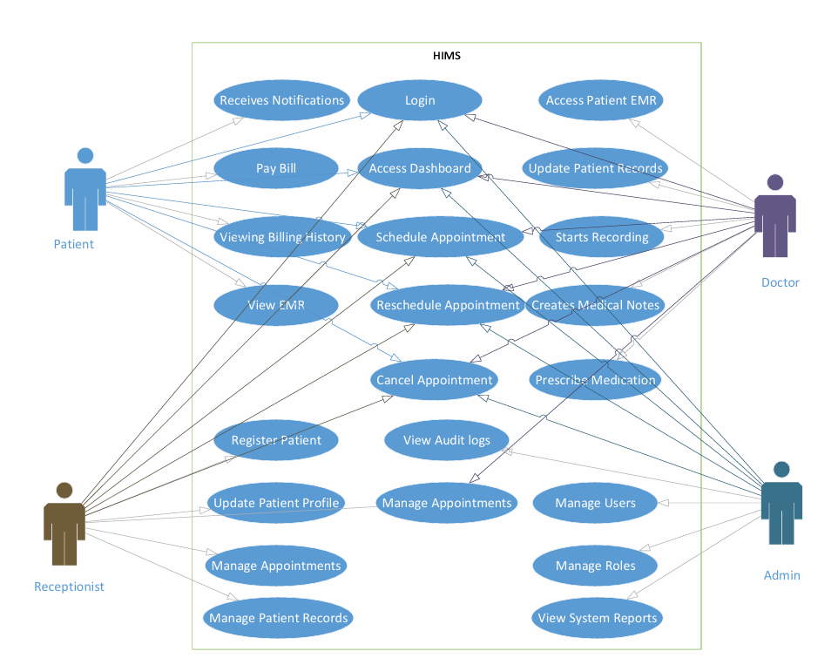
Figure 3.0 Use Case Diagram
  - System Level Architecture
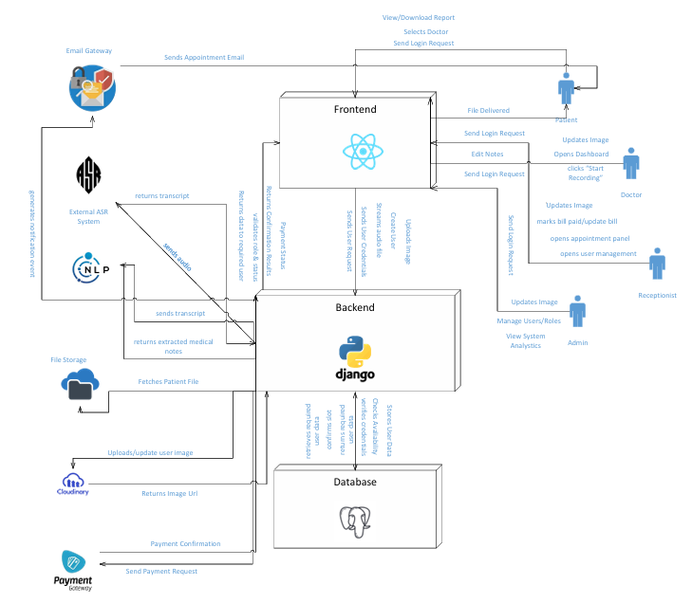
Figure 3.1 System Architecture Diagram

  - Sub-System / Component / Module Level Architecture
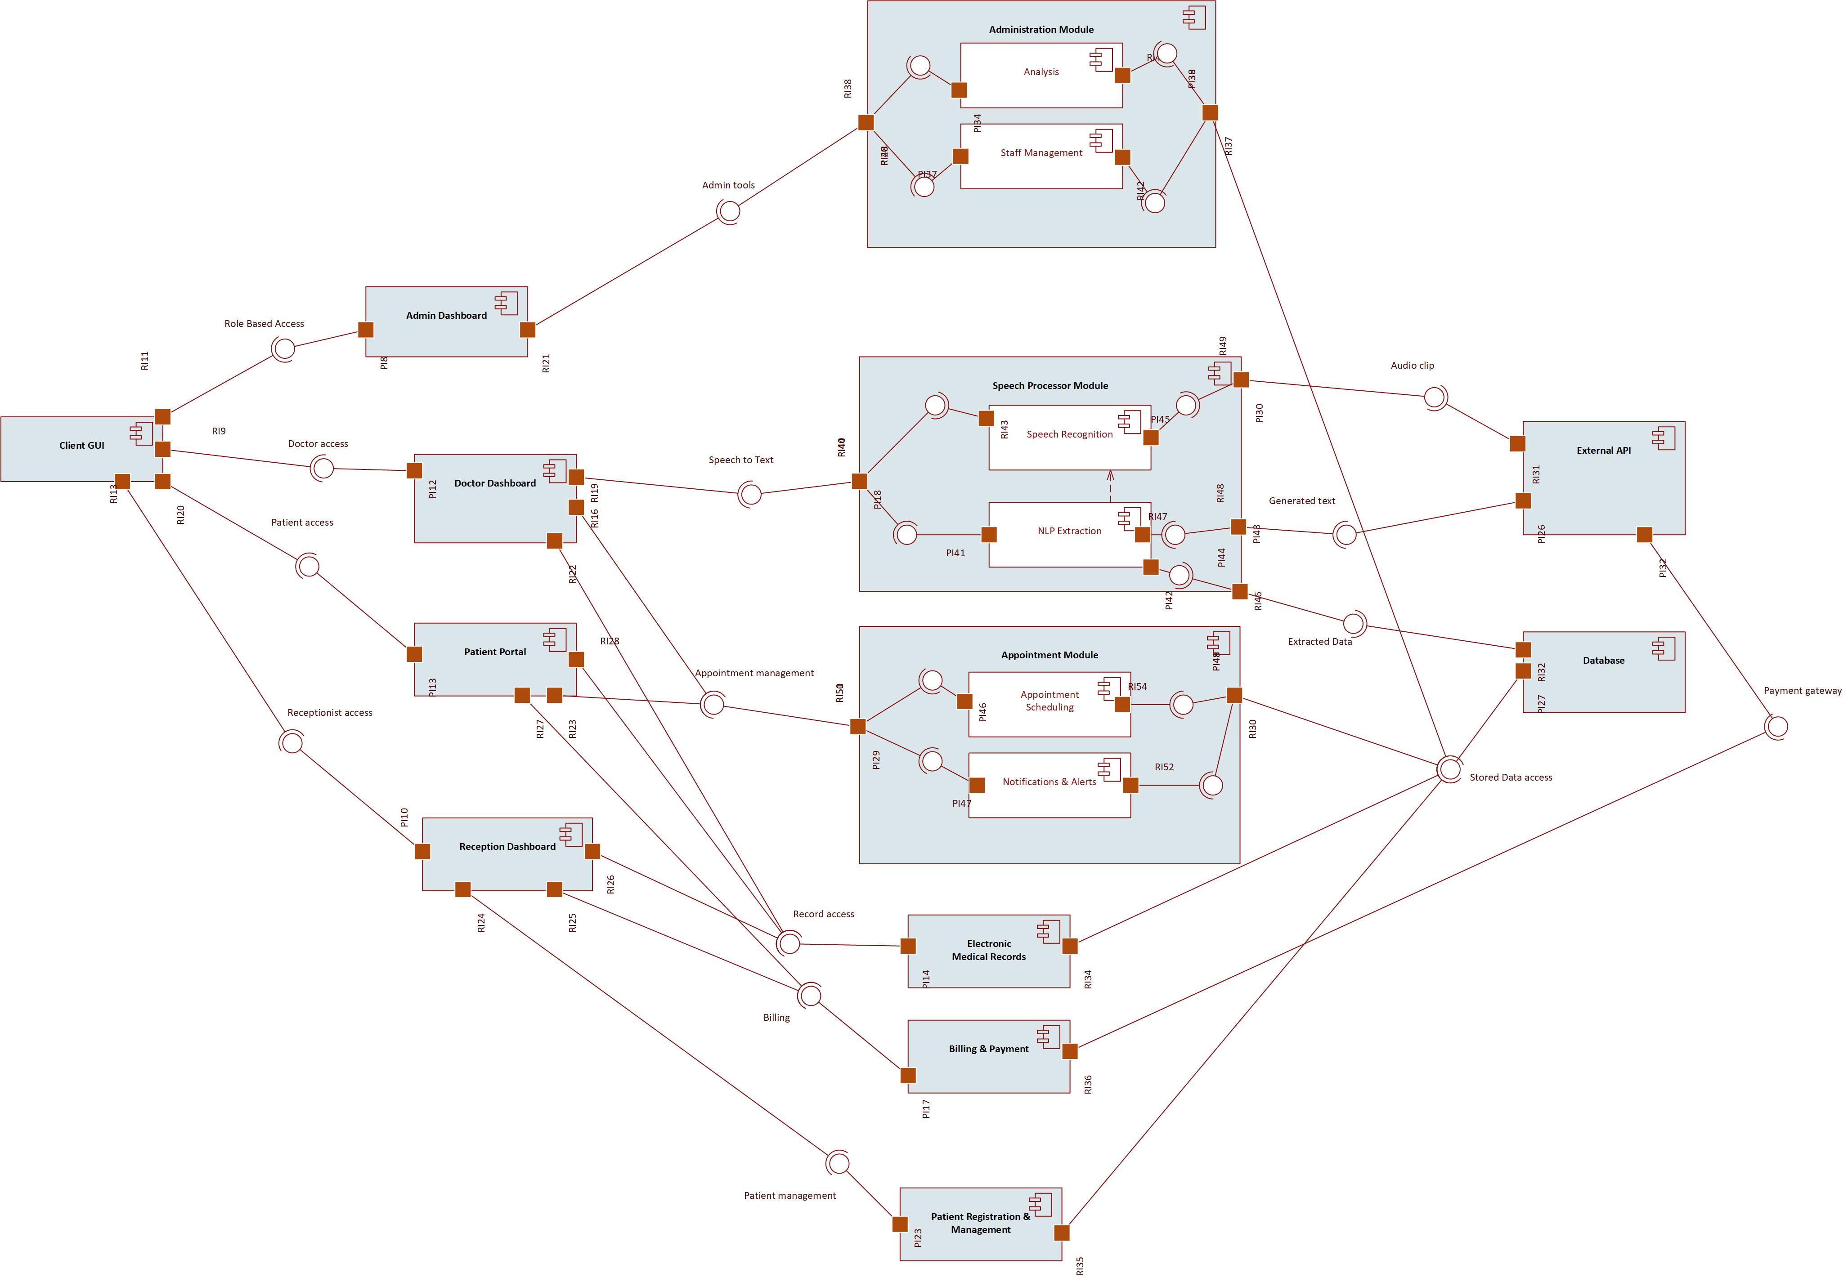
Figure 3.2 Component Diagram

  - Sub-Component / Sub-Module Level Architecture (1…n)
Identify all the sub components or sub modules (if any) of the already identified modules and components. Provide their diagrammatic view using appropriate detailed architecture diagram presenting how those sub systems, modules and components are further divided into sub components and sub modules and how they interact with each other.

Design Strategies
Describe the design strategies or decisions that impact the overall organization of the system and its high-level structures. This information should provide the reader with insights into the key abstractions and mechanisms used in the system architecture.

  - Strategy 1…n
For each strategy, discuss the reasoning employed (possibly referring to previously stated design goals and principles) and any trade-offs. Areas for consideration include:

- Future system extension or enhancement
- System reuse
- User interface paradigms
- Data management (storage, distribution, persistence)
- Concurrency and synchronization

Detailed System Design

  - Class Diagram

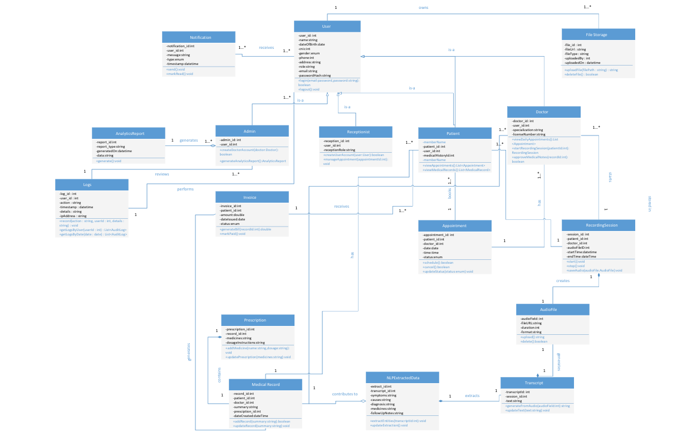
Figure 5.1 Class Diagram

  - ER Diagram

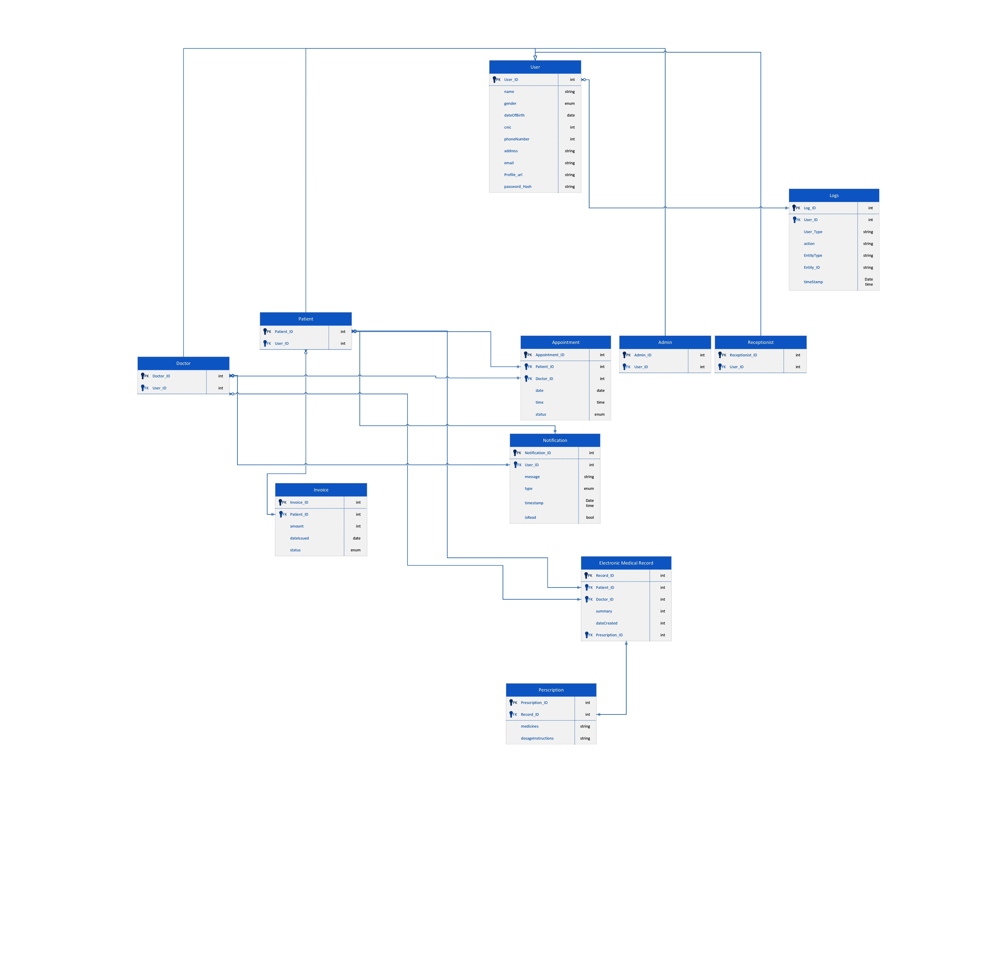

Figure 5.2 ER Diagram

  - State Transition Diagram

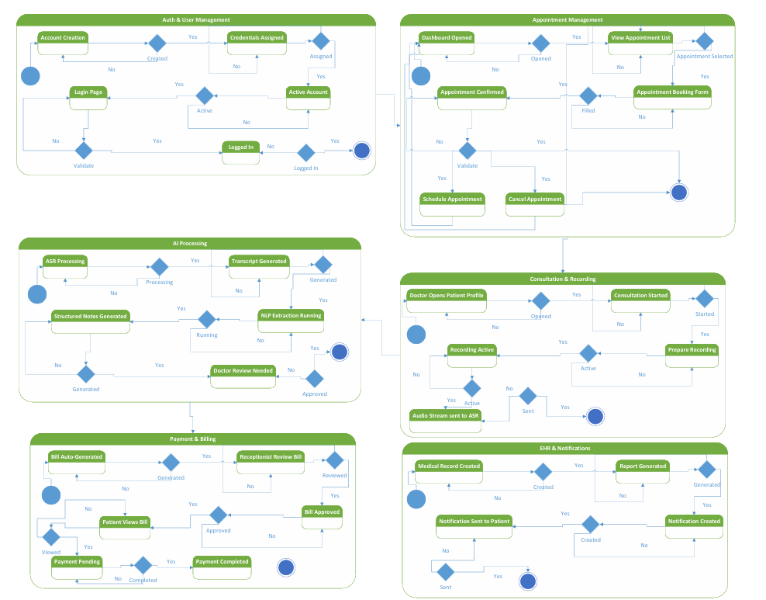
Figure 5.3 State Transition Diagram

  - Sequence Diagram

    - Sequence Diagram (Login)

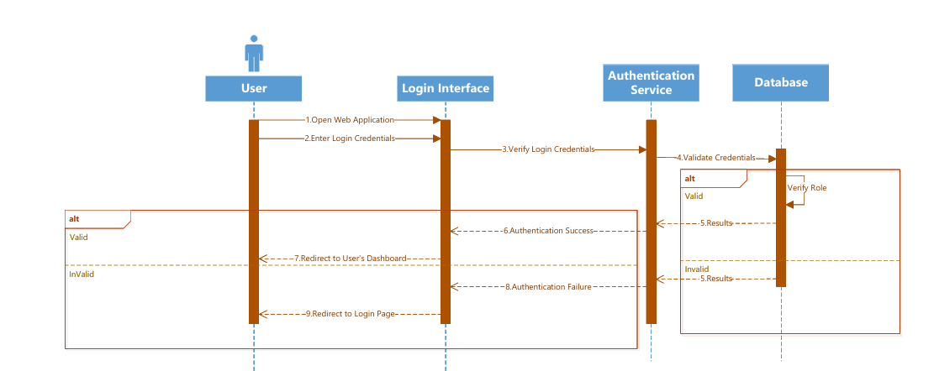
Figure 5.4.1 Sequence Diagram (Login)

    - Sequence Diagram (Patient)
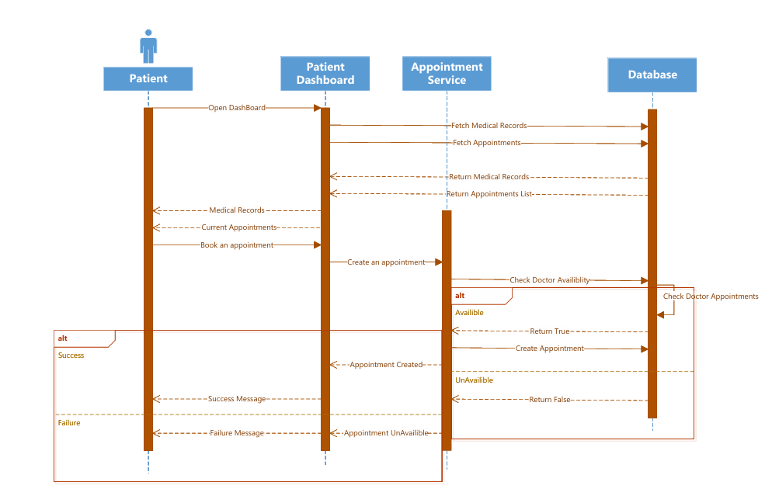
Figure 5.4.2 Sequence Diagram (Patient)

    - Sequence Diagram (Doctor)

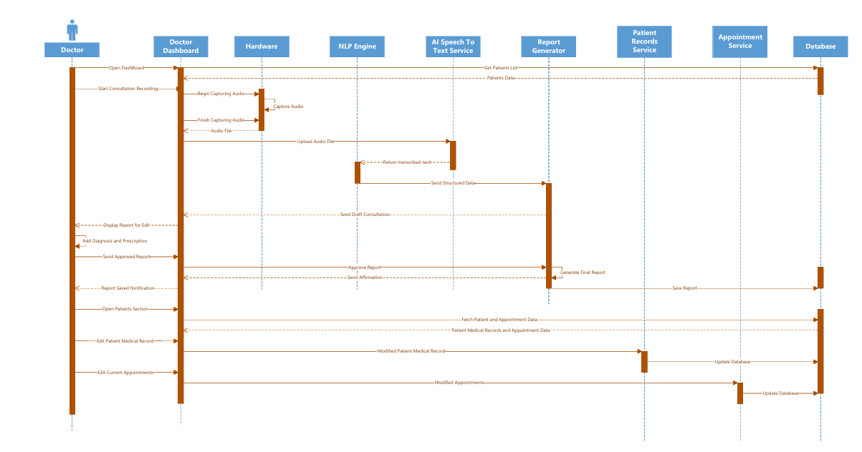
Figure 5.4.3 Sequence Diagram (Doctor)

    - Sequence Diagram (Receptionist)

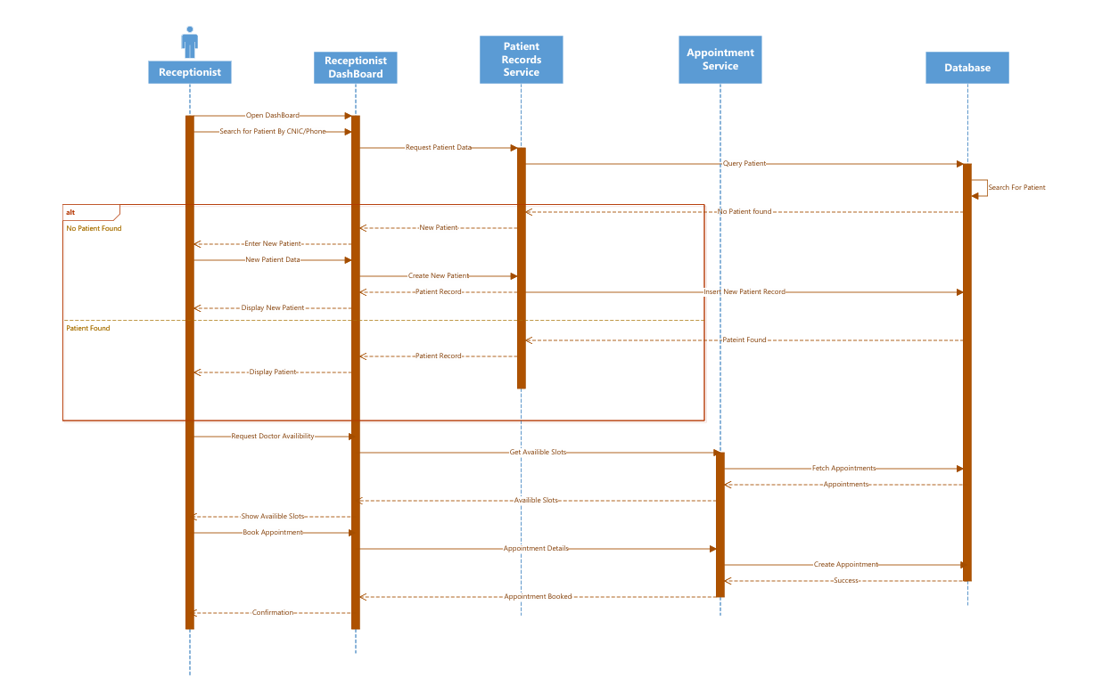
Figure 5.4.3 Sequence Diagram (Receptionist)

    - Sequence Diagram (Admin)

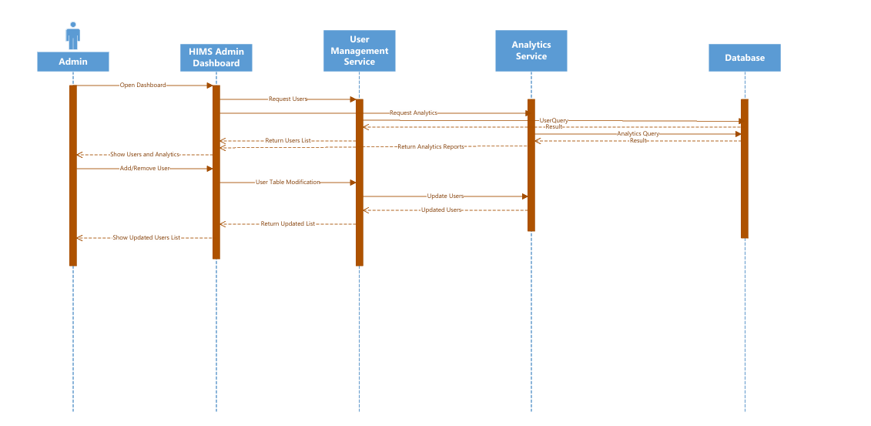
Figure 5.4.5 Sequence Diagram (Admin)

  - Data Flow Diagram

    - DFD Level 0

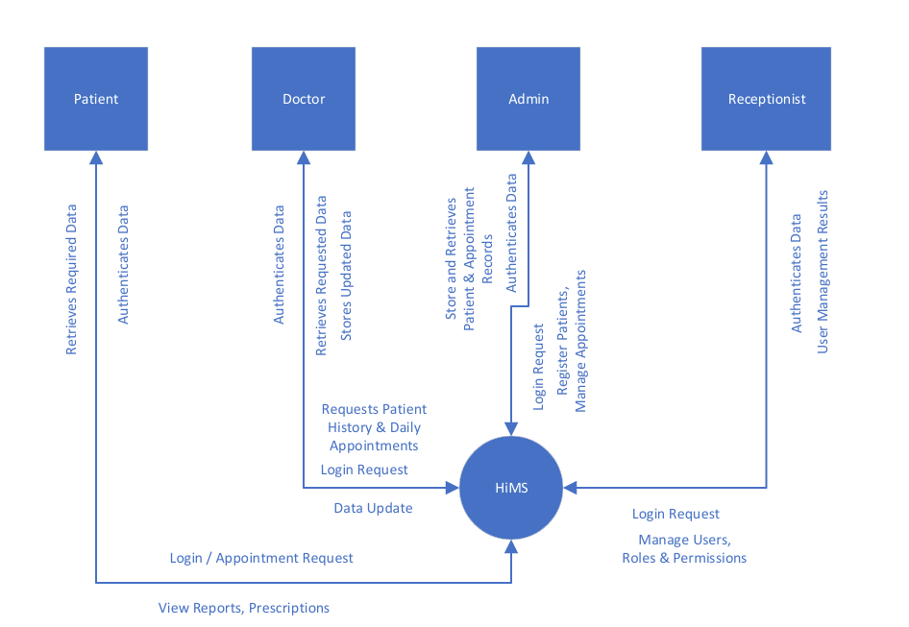
Figure 5.5.1 DFD Diagram (Level 0)

    - DFD Level 1

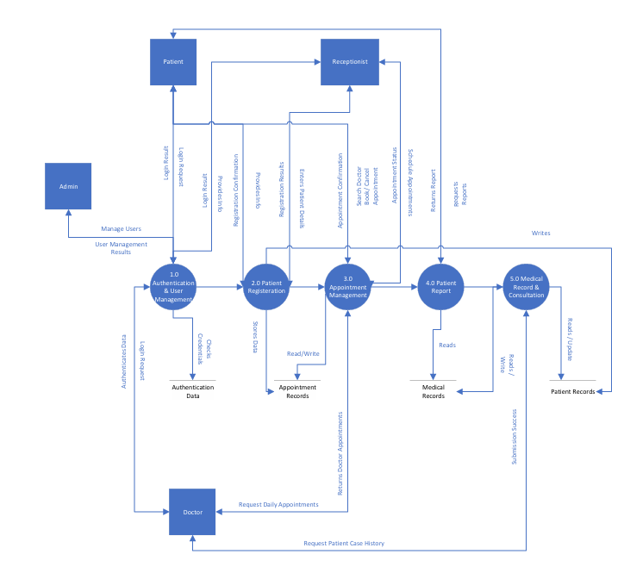
Figure 5.5.2 DFD Diagram (Level 1)
    - DFD Level 2

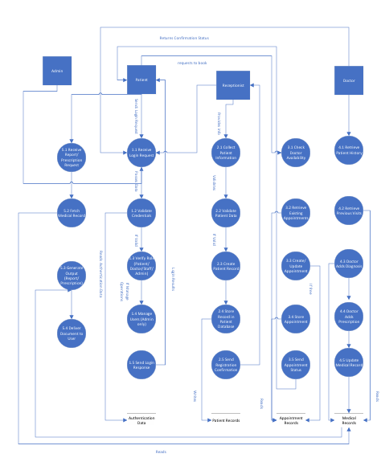
Figure 5.5.3 DFD Diagram (Level 2)

5.6 GUI

References
This section should provide a complete list of all documents referenced at specific point in time. Each document should be identified by title, report number (if applicable), date, and publishing organization. Specify the sources from which the references can be obtained (This section is like the bibliography in a published book).

Ref. No. | Document Title | Date of Release/ Publication | Document Source
PGBH01-2003-Proposal | Project Proposal | Oct 20, 2003 | <Give the path of your Project repository/Folder>
PGBH01-2003-FS | Functional Specification | Oct 20, 2003 | <Give the path of your Project repository/Folder>

Appendices
Include supporting detail that would be too distracting to include in the main body of the document.

